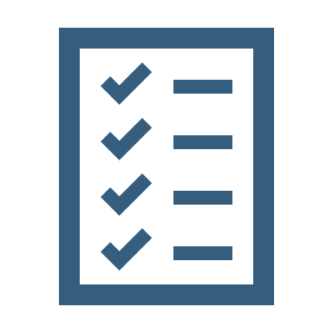  My  Safety Plan  Name:  Preferred name:  DOB:  Pronouns:  My background; tell us about you  Note: take a photo of this for your phone so you can access anywhere.  Date completed:  Review date:  Completed by: | Things I am concerned about Things others may be concerned about  Emotional & Mental Health Emotional & Mental Health  Physical Health Physical Health  Home, Financial & Legal Home, Financial & Legal  Physical Environment Physical Environment  Alcohol & Other Drugs Alcohol & Other Drugs  Family & Domestic Violence Family & Domestic Violence  Aggression & Violence Aggression & Violence  Other Other  Do you have a diagnosis and/or other information you would like to share?  Current Situation/ Summary of Concerns & Presenting Issues  Risk management is a dedicated process to increase safety and develop a plan to reduce potential issues and improve outcomes.  My Emotional & Mental Health (if relevant)  Signs I am well;  Signs I am becoming unwell;  Signs I am unwell;  Triggers you need to know about;  Risk management is a dedicated process to increase safety and develop a plan to reduce potential issues and improve outcomes.  Creating an Action Plan is so we can help safety plan, to avoid unsafe situations and so we know the best way to support you.  My Action Plan  Things I can do;  Things others can do;  Things you should never do;  Other or comments;  Escalation Points (At what point should a welfare check/ ambulance/police be called?)
Support
Who are your informal and inform supports and if relevant, how do we contact them if we are worried?

Consent
Please let us know who would you like us to share this form with? (can highlight above)

Some Helplines

Kids Helpline Phone: 1800 55 1800 / Website: https://kidshelpline.com.au/
Free, confidential counselling service available any time of the day or night by phone or webchat.

Beyond Blue Phone: 1300 22 4636 / Website: https://www.beyondblue.org.au/get-support/get-immediate-support
Call or chat online with a trained mental health professional any time of the day or night.

Alcohol and Drug Support Line: Phone: (08) 9442 5000 / Website: https://www.mhc.wa.gov.au/about-us/our-services/alcohol-and-drug-support-service/
The Alcohol and Drug Support Line is a 24/7 confidential, non-judgmental telephone counselling, information and referral service for anyone seeking help for their own or another person’s alcohol or drug use.

Some web support & information

eheadspace: Phone: 1800 650 890 / Website: https://headspace.org.au/eheadspace/
eheadspace provides free online and telephone support and counselling to young people 12 - 25 and their families and friends. If you’re based in Australia and going through a tough time, eheadspace can help.

Children of Parents with a Mental Illness (COPMI): Website: http://www.copmi.net.au/kids-young-people
Having a parent with a mental illness can be tough. But COPMI have a lot of information and videos to help you get your head around it all.

