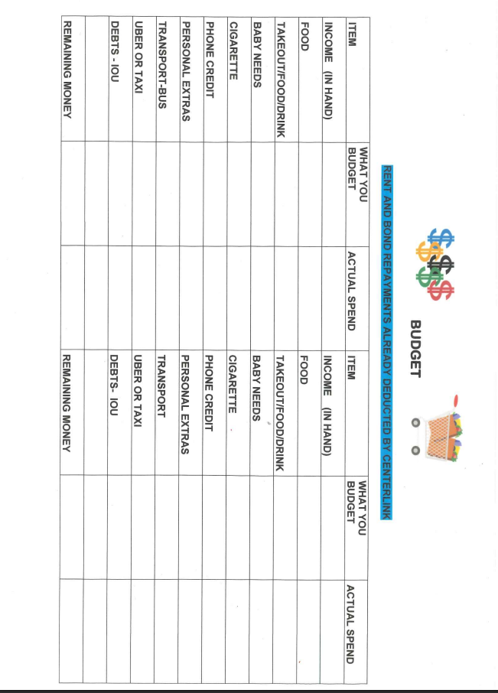

**BUDGET TEMPLATE**

|  |  |  |  |  |
| --- | --- | --- | --- | --- |
| EXPENSES | WEEK 1 BUDGET | WEEK 1 ACTUAL SPEND | WEEK 2 BUDGET | WEEK 2 ACTUAL SPEND |
| INCOME |  |  |  |  |
| RENT |  |  |  |  |
| FOOD |  |  |  |  |
| MOBILE PHONE |  |  |  |  |
| ELECTRICITY |  |  |  |  |
| GAS |  |  |  |  |
| TRANSPORT  CAR/PUBLIC/UBER |  |  |  |  |
| BABY NEEDS  NAPPIES/FORMULA |  |  |  |  |
| TAKEAWAY |  |  |  |  |
| DEBTS/FINES |  |  |  |  |
|  |  |  |  |  |
|  |  |  |  |  |
|  |  |  |  |  |
|  |  |  |  |  |
|  |  |  |  |  |
| TOTAL SPEND |  |  |  |  |
| TOTAL DIFFERENCE -/+ |  |  |  |  |

***Budgeting tips***

Budgeting starts with a pen and paper before your payment hits your bank account. Note down ALL your due accounts, add to this food, fuel, phone, synergy, rent, anything that needs to be paid this week A budget also helps you to park that stress that comes with money

I will attach a template you may like to copy or hit me up for a laminated one. Budgeting is only going to work if your honest with yourself about your spending.

***Finding out how much extra you are spending***, for one week when you get home note down everything your spent, drink for you, treat for bub, that small toy, hot chips quick lunch, coffee, everything you bought write down for 1 week at the end of the week add it up you may be surprised at what you spend without realising. I used to buy a coffee or 2 each day $10+ each day x 4 days that’s $40 per week $2080 a year (check out my car you will see my takeout coffee cup I take one with me from home now) I also try to take my lunch to work with me that’s also another $10 a day I save.

***Meal planning***, who meal plans I find this is a great way to help with a shopping list and to keep an eye on your food spent. Not to mention taking the pain out of deciding what to cook each night if you don’t have a white board or similar use your fridge as a whiteboard (write on it)

***My weekly menu plan***

*Monday*; spag bog

*Tuesday;* taco Tuesday

*Wednesday;* soup

*Thursday;* chicken pasta

*Friday;* fake away (Coles fresh pizza $5 each)

*Saturday;* slow cooker meal

*Sunday;* baked beans or eggs on toast

Write a list of your favs and mix them up each week

Cook double and freeze half, nothing better than I’m too tired to cook or get home late, grab a meal out of the freezer and ready to eat, this is also great for when you’re on a week where lots of bills have left the bank account looking sad

I’m happy to sit with you and help to work out a budget that is going to work. Call me and book me in for this, don’t forget we also have financial counselling FREE to you

|  |  |  |  |  |
| --- | --- | --- | --- | --- |
|  | BREAKFAST | LUNCH | DINNER | SNACKS |
| **MONDAY** |  |  |  |  |
| **TUESDAY** |  |  |  |  |
| **WEDNESDAY** |  |  |  |  |
| **THURSDAY** |  |  |  |  |
| **FRIDAY** |  |  |  |  |
| **SATURDAY** |  |  |  |  |
| **SUNDAY** |  |  |  |  |

